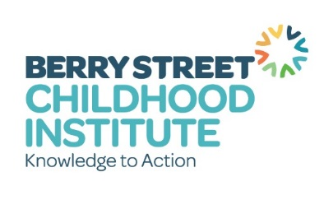
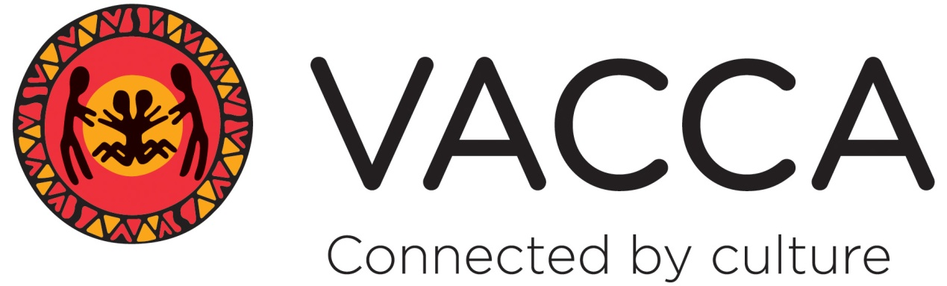

Family Finding Overview

What is Family Finding?
The Family Finding model, developed by Kevin A. Campbell, National Institute for Permanent Family Connectedness, USA (www.familyfinding.org), offers methods and strategies to locate and engage relatives and other family connections (kith, kin and community) for children who are involved at any point in the child protection system, including those living in out-of-home care.

Core beliefs inherent in this approach are:
- Every child has a family, and they can be found if we try;
- Loneliness can be devastating, even dangerous, and is experienced by most children in out-of-home care;
- A meaningful connection to family helps a child develop a sense of belonging; and
- The single factor most closely associated with positive outcomes for children is meaningful, lifelong connections to family (kith and kin).
The revised model (based on Randomised Control Trials and qualitative studies) has two phases, and is outlined below. No evaluation of the revised model exists as it has only been operational since July 2015.

(Phase 1) Foundation steps before Family Finding:
Essential steps to be completed by the Family Finder with the case manager and child protection staff (with decision making ability) before beginning the Family Finding Process.
- Statement of Needs and Concerns (this refers to the permanency needs)
- Purpose and Goals (of Family Finding in establishing a Lifetime Network)
3. Authentic Commitment
The level of authentic commitment to sustaining the process (including full family participation) of each professional is determined using an informal (likert) authenticity scale. Without sufficient commitment, Family Finding should not be undertaken and others may need to be consulted.
- Therapeutic Support (for the child throughout the process; this does not need to be a therapist, but the person needs to have an understanding of therapeutic process)
(Phase 2) Active Steps of Family Finding: Developing the Lifetime Network:
- Engage child or young person and family
Discussion of Family Finding with the child /young person to obtain her/his agreement to participate; and, engage the child/young person and important adults (particularly parents) in identifying who to include in the search and engagement. The search is not limited by this, but may suggest who should be prioritised for initial contact and searching.

- Search
Review previous searches and who is known to services, contact people named by the child & family; read CSO and DHHS files for further contact information; use data bases to discover other family members or contact details. Find 40 kith and kin from both sides of the family, and from kith (friends) and community.
- Preparation and Blended Perspectives meeting
Preparation work with interested family members and other important adults, caregiver, case manager, child protection decision maker before they participate in the Blended Perspective Meeting. The Blended Perspectives meeting brings together kith, kin and workers for the purpose of gaining a clear, common understanding of the child’s needs, the strengths and concerns of the situation, and anything that is definitely “out” (bottomlines) or must be definitely “in” (such as contact with community - so planning can commence.
- Three plans meeting (Planning and Decision making)
Using a family group conferencing model, the kith and kin creates 3 plans that are sustainable and meet child protection ‘bottom lines’. Child protection (and cultural planners where relevant) review the plans so they meet case planning requirements, at this meeting, with the proviso that any kinship care assessment (if it’s needed) is satisfactory.
- Lifetime Network
Lifetime Network becomes the core planning, doing and supporting force in child/young person’s life; advocates for educational success, health care, and normative community/social experiences. They implement the plans so that permanency is achieved. The case manager remains involved and increasingly becomes the content expert, voice for the agency and timekeeper for moving the process along to permanency.
- Healing and Development
Network members explore with case manager, and continue to monitor, the evidence-informed care and models of therapeutic treatment that may be offered.
- Legal Permanency.
The Network continues efforts to create a permanent living situation with a safe and caring adult. Family Finding is complete when a child/young person has established relationships with family members who will support, welcome and sustain him for a lifetime and the Lifetime Network has accepted responsibility for continuing permanency efforts.

Berry Street and VACCA’s proposed plan
Berry Street and VACCA have committed internal resource (March 2016 to June 2018) for a proof of concept for the Family Finding Model and its applicability in the Victorian and Australian context. Berry Street and VACCA workers will undertake specific training, and some information sessions will be held for other workers to allow discussion about the process, roles and expectations. The model will be implemented with fidelity, and evaluations of practice and outcomes will form a part of the proof of concept.

